Board of Fire Commissioners
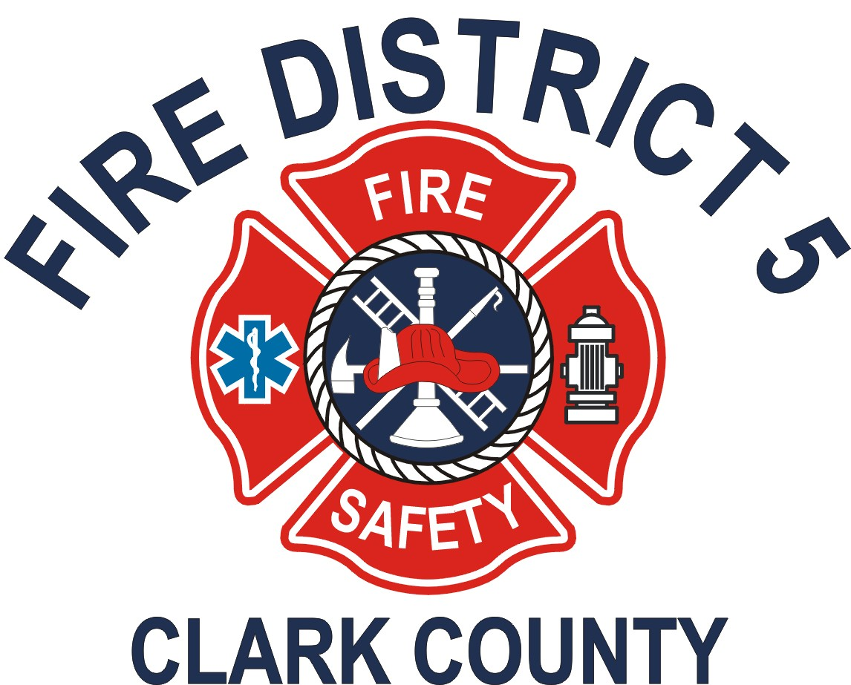

Clark County Fire District 5

Revised Regular Meeting Agenda

April 21, 2026

11606 NE 66th Street, Suite 103
Vancouver, WA 98662

- Call Meeting to Order – 5:30 pm
- Approval of Minutes
March 3, 2026 Regular Meeting
- Chief’s Report
- Citizen’s Communication
This is the place on the agenda where the public and/or employees are invited to speak to the board on any item not on the agenda, or to indicate to the chairman a desire to speak to the board on an agenda item when that item is brought up for discussion. In every case, the person speaking shall give his or her name and address for the record.
- Consent Agenda
- Commissioners’ Fund 6209 $ 32,539.80
- Commissioners’ Fund 6209 $ 7,790.79
- Commissioners' Fund 6209 $ 2,421.38
- Commissioners’ Fund 6209 $ 13,702.41
- Commissioners' Fund 6209 $ 23,600.97
- Commissioners' Fund 6209 $ 8,924.82
- Commissioners' Fund 6209 $ 26,356.44
- Payroll Transmittal – February 16 to 28, 2026 $ 28,040.16
- Payroll Transmittal – March 1 to 15, 2026 $ 31,202.05
- Payroll Transmittal – March 16 to 31, 2026 $ 33,979.87
K. Sales Refunds – March 2026 $ 8148.79
- Secretary’s Report
- Commissioners Fund Financials – March 2026
- Classes Taught – March 2026
- New CPA Firm
- Sales tax recoup
- Updates to Employee Handbook
- Board Communications
This is the place where the Commissioners and the Secretary to the Board discuss items not listed in this agenda.
- Old Business
None.
- New Business
- Dizzy Castle Lease Renewal
- Draft of Amendment to Fire Services Agreement Section 6
- Adjournment

